**Task No 1: Write a Program in C++ That Displays the Sum of First 10 odd**

**Multiples of 3.**

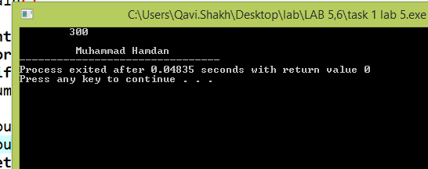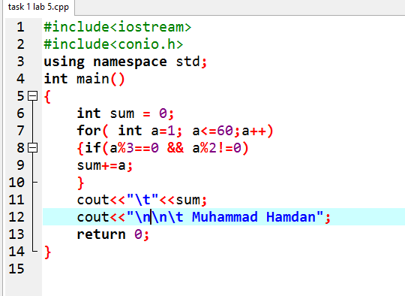

**Task No 2: Write a Program in C++ That Asks the User To Input The Starting**

**Number and Ending Number of the Range. The Program Should Display The**

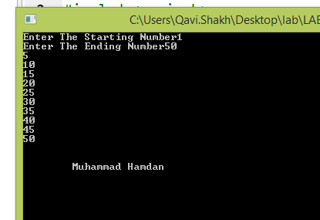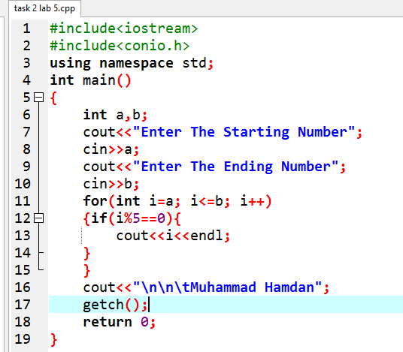**Number of Multiples of 5 In Between That Range.**

**Task # 3: A A A A**

**A A A**

**A A**

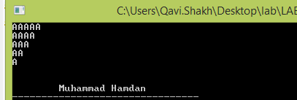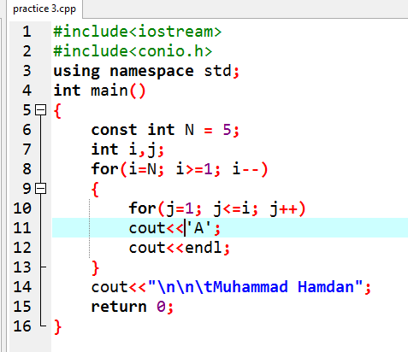 **A.**